A

CASE STUDY

Is Gender a Significant Factor in the Increase of the Number of Heterosexual Partners in the Last Decade?

KREATIVSTORM DATA ANALYSIS HANDS-ON PROGRAMME (GROUP B.4)

INTRODUCTION

Understanding the nature and level of heterosexual activities in the society is important and useful in many ways. An increase or decline in the number of heterosexual partners could be a direct indicator of the level of sexual activity in a society. In one dimension, a high level of sexual activity could be positive, signaling sound health, well-being, and high quality of life (Wellings et al., 2019). Research evidence suggests that people that have active sexual lifestyle are more physically fit, enjoy life more, posses better cognitive function, increased life expectancy, protection against cardiovascular diseases and reduced stress(Blanch Flower and Oswald, 2004; Cheng & Smith, 2015; Mounder et al., 2017; Lorenz et al., 2018; Ebrahim, 2002). On the other hand, having a high number of heterosexual partners could have negative consequences including spread of sexually transmitted diseases(Dougan et al., 2005; Brison et al.; Hunter,1993). Adding to past studies on the impact of numbers of heterosexual partners on the society and public well being, this research aims to further provide more insight on this topic by evaluating gender-based impact on the increase of the number of heterosexual partners in a 10-year period(2000-2010) through rigorous analysis of the NSSAL-2* and NSSAL-3* datasets. This research will be useful to public health policy planners and administrators in creating effectively targeted policies and awareness campaigns relating to sex. Public health researchers will find the information from the analysis of data useful for their research, companies interested in creating drugs for sexually transmitted diseases (STDs) can use the findings of this research to track the trajectory of the occurrence of STDs for each gender class and forecast demand for drugs.

DATASET DESCRIPTION

For this research, the following datasets were used for our analysis

The NSSAL-2 dataset was gotten from a survey conducted between 1999 and 2001 by the British National Surveys of Sexual Attitudes and Lifestyles.

The NSSAL-3 dataset was gotten from a survey conducted between 1999 and 2001 by the British National Surveys of Sexual Attitudes and Lifestyles.

The NSSAL-2 sample consisted of 12735 adults aged 16-74 and 1106 variables. NSSAL-3 sample consists of 15162 adults aged 16-74 from the UK and 1224 variable.

To answer the research question, 2 variables were deemed necessary for our analysis. These are

“hetlife” - which is the number of heterosexual partners for a given individual for life as at the time of the survey

“rsex” – their gender(1 represent male, 2 represent female)

METHODOLOGY

Exploratory Data Analysis

Descriptive analysis of the datasets was carried out to understand the shape and distribution of the selected variables. In each dataset, the number of heterosexual partners for each gender class was plotted in a histogram chart to aid comparison of the distributions. Box plot diagrams were also plotted to compare the distribution of the number of heterosexual partners for each group. The box plot diagram also allowed us to see if there are outliers in our dataset. Further descriptive statistics like determining the mean, median, minimum value, maximum value, standard deviation, homogeneity and skewness of the distribution were checked.

Hypothesis Testing

For the two different datasets, we tested for a difference in the number of heterosexual partners for the two gender class using t-tests.

Testing for Interactions

By making use of 2-way ANOVA for combined dataset, the interaction effect of gender and time was measured to further determine if gender is a significant factor in the increase of heterosexual partners. For this purpose, we combined our two datasets into one dataset. This was done by putting the “hetlife” variable for both datasets in the same column. A year column was created with “1” representing observations from the NASSL-2 dataset and “2” representing observations from the NASSL-3 dataset, “rsex” variables from the two years were combined into one. To summarize, our combined dataset for the two way ANOVA has the following variables. “rsex”, “year” and “hetlife”.

Assumptions for the use of the T-test (Field, 2019)

Normality – the sampling distribution of the data should be normal. While the descriptive analysis of the datasets showed that the data is highly skewed, we invoke the central limit theorem which states that the distribution of the mean converges to normal distribution for very large sample sizes (Gravetter,2013). Furthermore, given that the data for the two gender class in both surveys are similarly skewed, any error inherent in the test as a result of the assumption of normality of the mean for one group will have the same effect on the other group and will cancel each other out to produce a reasonable result.

Interval/Continuous data- The measured variable is continuous

Independence: our datasets contain independent observations given that the values of the variables are gotten from the response of different individuals.

The assumptions for the use of two-way ANOVA (Field 2019)

Normality of the data - Once again we invoke the central limit theorem to justify the normality of the sampling distribution

Homogeneity – while the cells are not homogenous, two-way ANOVA is robust to heterogeneity of variances especially when the sample size is very large(n>>30)

Interval variable – Our dataset is continuous

Discussion of results and Findings

Descriptive analysis for the NSSL-2 dataset

Fig. 1

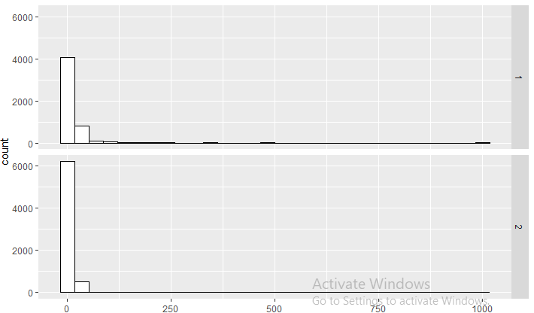

Fig. 1 is a histogram plot of the dataset before removal of outlier for the NASSL-2 survey

Fig 2.

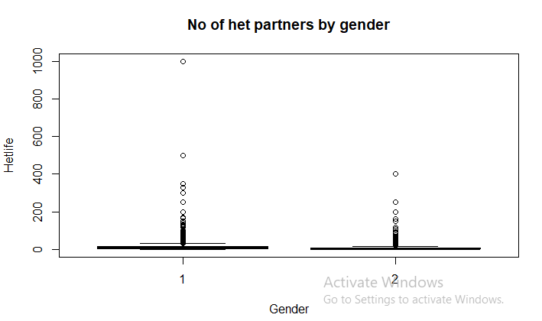

Fig 2. Is the number of heterosexual partners for the two gender classes

Total number of significant outliers(z-score value greater than 3.3) for the two groups in the dataset is 105. Except for a few outliers(greater than or equal to 300 for male, greater than or equal to 150 for female), Almost all the outliers are not removed from the data as they are many and reflect the true variation in the number of heterosexual partners in real life.

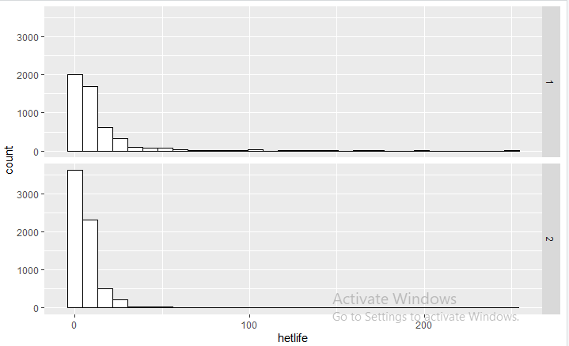

Fig. 3 is a histogram plot of the dataset after removal of extreme outliers for the NASSL-2 survey

The mean of the number of heterosexual partner for male is 12.2 with 95% CI(11.62, 12.78) while the mean for female is 6.60 with 95% CI (6.39, 6.81). Note that the estimation of confidence intervals used the assumption that the distribution of the sampling mean is approximately normal for large samples. This has been done before in previous research by Kault (1996) in his work on the distribution of number of heterosexual partners where he clearly stated the confidence intervals are reliable only for large sample sizes. There is heterogeneity of data with p-value very well less than 0.05

T-test result for NSSL-2 dataset.

The test-t result for NSSL-2 revealed that there is a significant difference between the number of heterosexual partners for the male and the female gender with t(11791) = 17.815 and p-value less than 0.05 level of significance

Descriptive analysis for the NSSL-3 dataset

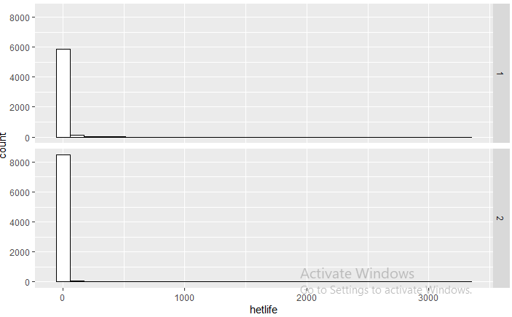

Fig. 4 is a histogram plot of the dataset before removal of outliers for the NSSL-3 survey

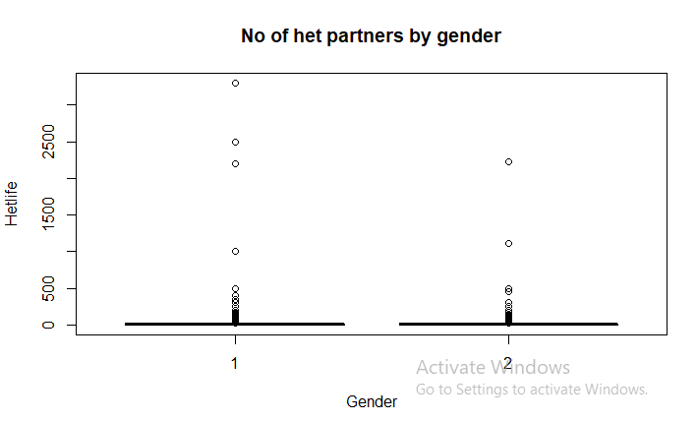

Fig 5. Is the number of heterosexual partners for the two gender classes

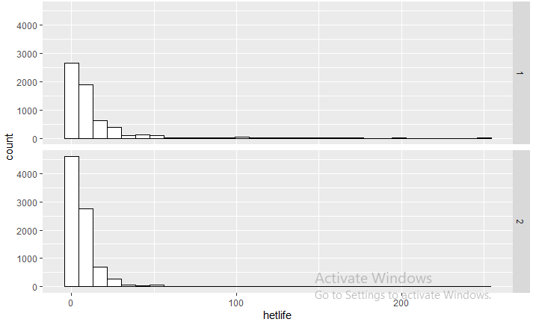

Fig. 6 is a histogram plot of the dataset after removal of extreme outliers for the NASSL-3 survey

The mean of the number of heterosexual partner for male is 11.56 while the mean for female is 6.89. There is heterogeneity of data with p-value greatly less than 0.05

T-test for NSSL-3 dataset

The t-test result for NSSL-3 revealed that there is a significant difference between the number of heterosexual partners for the male and the female gender with t(14523) = 16.916 and p-value less than 0.05

Test for Interaction

With a F (1, 26326) = 6.467, p-value of 0.011, The two-way ANOVA confirmed that there is an interaction of gender and time variable with regards to the number of heterosexual partners

SUMMARY AND CONCLUSION

The table below summarizes the result of the analysis.

|  |  |  |  |
| --- | --- | --- | --- |
|  | NSSL 2(avg. no of het partners) | NSSL-3(avg. no of het partners) | Interaction(p-value) |
| MALE | 12.2 | 11.59 | 0.011 |
| FEMALE | 6.6 | 6.89 |  |

While the Average number of heterosexual partners in the last decade decreased for the male gender, the Average number of heterosexual partner increased although slightly from 6.6 to 6.89 for the female gender with a significant interaction p-value. The male gender still has the highest tendency to have more heterosexual partners, but the gap is narrowing due to more noticeable increase in the number of heterosexual partners by female gender in the ten year period that was studied. This research concludes by asserting that gender is a significant factor in the increase of heterosexual partners in the last decade

REFERENCES

McMahon, J.M., Tortu, S., Torres, L. *et al.* Recruitment of heterosexual couples in public health research: a study protocol. *BMC Med Res Methodol* **3**, 24 (2003). <https://doi.org/10.1186/1471-2288-3-24>

Dougan S, Gilbart V L, Sinka K, Evans B G. HIV infections acquired through heterosexual intercourse in the United Kingdom: findings from national surveillance BMJ 2005; 330 :1303 doi:10.1136/bmj.38393.572188.EB

Wellings K, Palmer M J, Machiyama K, Slaymaker E. Changes in, and factors associated with, frequency of sex in Britain: evidence from three National Surveys of Sexual Attitudes and Lifestyles (Natsal) BMJ 2019; 365 :l1525 doi:10.1136/bmj.l1525

Kault D. The shape of the distribution of the number of sexual partners. Stat Med. 1996 Jan 30;15(2):221-30. doi: 10.1002/(SICI)1097-0258(19960130)15:2<221::AID-SIM148>3.0.CO;2-Q. PMID: 8614756.

Blanchflower DG, Oswald AJ. Money, sex, and happiness: an empirical study. Scand J Econ2004;106:393-415doi:10.1111/j.0347-0520.2004.00369.x

Cheng Z, Smyth R. Sex and happiness. J Econ Behav Organ2015;112:26-32doi:10.1016/j.jebo.2014.12.030

Maunder L, Schoemaker D, Pruessner JC. Frequency of penile-vaginal intercourse is associated with verbal recognition performance in adult women. Arch Sex Behav2017;46:441-53. doi:10.1007/s10508-016-0890-4 pmid:27844312

Lorenz TK, Heiman JR, Demas GE. Interactions among sexual activity, menstrual cycle phase, and immune function in healthy women. J Sex Res2018;55:1087-95. doi:10.1080/00224499.2017.1394961 pmid:29161177

Ebrahim S, May M, Ben Shlomo Y, et al. Sexual intercourse and risk of ischaemic stroke and coronary heart disease: the Caerphilly study. J Epidemiol Community Health2002;56:99-102. doi:10.1136/jech.56.2.99 pmid:11812807

Brisson M, Boily MC, Mâsse BR, Adrien A, Léaune V. Highlights of the sexual activity of the heterosexual population in the province of Quebec. Sex Transm Infect. 1999 Oct;75(5):296-9. doi: 10.1136/sti.75.5.296. PMID: 10616351; PMCID: PMC1758244.

Hunter DJ. AIDS in sub-Saharan Africa: the epidemiology of heterosexual transmission and the prospects for prevention. Epidemiology. 1993 Jan;4(1):63-72. PMID: 8420583.

Gravetter F.J . & Wallnau L.B.(2013),Statistics for Behavioural Sciences(9th edition). Belmont,CA. Wadsward\Thompson Learning.

Field A. 2009. Discovering Statistics using SPSS(3rd ed.) London, UK: SAGE publications Ltd